Activity on kinases

**1. Questions to the text**

* Functions of the Src kinase?   
  It’s a signalling protein which is involved into control of cellular growth, cell structure and cell communication. It adds phosphate groups to special tyrosine amino acids in protein which are included in the mentioned actions. By adding the phosphate groups, Scr kinase turns the proteins on.
* Is there only one Src kinase?  
  No, the researchers have discovered hundreds of tyrosine kinases which are very simila to the Src kinase, such as Hck or Abl.
* What’s the difference between v-Scr and c-Src?  
  The v-Scr comes from a virus called Rous virus, the c-Src is the cellular one. The viral Scr is constantly active and can cause cancer.
* Purpose of durgs gainst Src?   
  The drug designed against Src is called Gleevec; it blocks the continually activity of Abl. Researchers try to inhibit the constant activity of theses kinases to restore normal growth.

**2. Name of the paper**  
🡪 Structural basis for the autoinhibition of c-Abl tyrosine kinase *(Nager at all)  
PMID: 12654251*

**3. Search for reviewed human Scr kinases with Src as protein family.**

* How many human Src are there?   
  10
* How many Uniref100? 🡪 **UniRef100** combines identical sequences and sub-fragments with 11 or more residues from any organism into a single UniRef entry.  
  10
* How many Unifre90? 🡪 **UniRef90** is built by clustering UniRef100 sequences such that each cluster is composed of sequences that have at least 90% sequence identity to, and 80% overlap with, the longest sequence (a.k.a. seed sequence).  
  10

**4. Align them all.**

* Can you find any region/ residues that are highly conserved?  
  Yes, DFG motive is present in all, so it’s a much conserved motif which is closed to the active site.
* How conserved is the active site residue?   
  The active site is really conserved; there is always a D (= aspartic acid) in every of the ten proteins. Asp is a negatively charged amino acid.  
  Also the region around the active site (aspartic acid) is really conserved; we observe in all ten proteins the same sequence: HR**D**L.
* Are there any variants around the active site residue?   
  Yes, there are natural variants in five of the ten proteins; three of them are in the DFG motif.

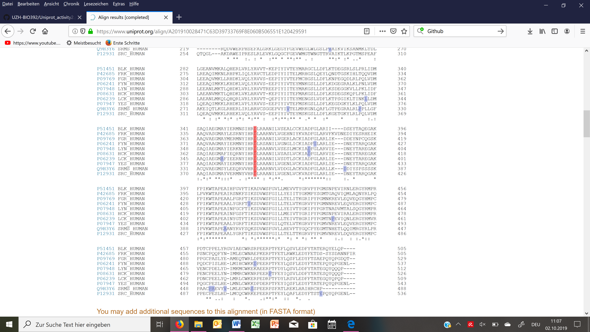  
*red= the active site  
blue = the natural variants  
* = indicates highly conserved motif*

**5. Visualization with Uniprot**

🡪 We picked the Scr kinas HCK (P08631). Because there are different PDB entries for the HCK, we took the one with the largest coverage. In our case, there were two which had the same coverage:

* 1AD5, position 79-526
* **2HCK, position 79-526**

For the visualization, we took 2HCK. The red dots in the picture are the water atoms.

